**EXPERIMENT 1**

**Source Code:**

package experiment1;

import java.util.*;

public class Experiment1 {

public static void factorial(Scanner sc){

int n,f=1;

System.out.println("Enter the number whose factorial is to be found: ");

n = sc.nextInt();

for(int i = 1; i <= n; i++){

f = f*i;

}

System.out.println("Factorial is : "+f);

}

public static void fibonacci(Scanner sc){

int n,a=0,b=1,c;

System.out.println("Enter the number upto which fibonacci series is to be found: ");

n = sc.nextInt();

System.out.println("Series is : ");

System.out.println(a+"\t"+b+"\t");

for(int i = 1; i <= n-1; i++){

c = a + b;

a = b;

b = c;

System.out.println(c+"\t");

}

}

public static void leapYear(Scanner sc){

int n;

System.out.println("Enter a year: ");

n = sc.nextInt();

if(n%4 == 0){

System.out.println(n+" is a leap year");

}else{

System.out.println(n+" is not a leap year");

}

}

public static void palindrome(Scanner sc){

int n,r=0,d,num;

System.out.println("Enter a number: ");

n = sc.nextInt();

num = n;

while(n!=0){

d = n%10;

r = r*10 + d;

n = n/10;

}

if(r==num){

System.out.println("Number is palindrome");

}else{

System.out.println("Number is not a palindrome");

}

}

public static void main(String[] args) {

Scanner sc=new Scanner(System.in);

System.out.println("Enter a choice:\n 1 For Factorial\n 2 For Fibonacci \n 3 For Leap Year\n 4 For palindrome");

int choice=sc.nextInt();

switch(choice){

case 1:factorial(sc);

break;

case 2:fibonacci(sc);break;

case 3:leapYear(sc);break;

case 4:palindrome(sc);break;

}

}

}

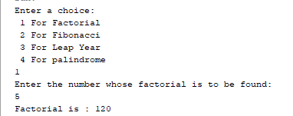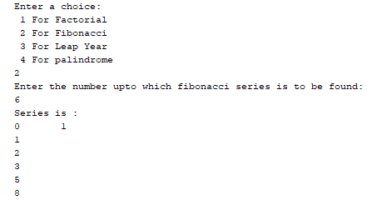**OUTPUT**

